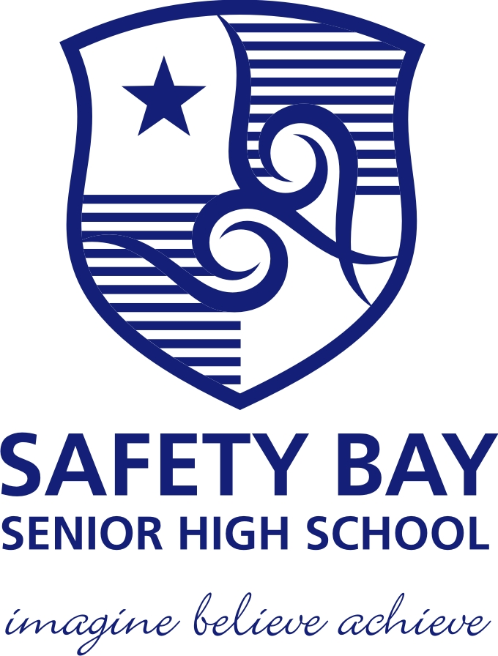**Safety Bay Senior High**

**Physics - Unit 1 – Task 6**

**Heating and Cooling Test**

**Name: Total Marks /52**

**Question 1:**

People who have not studied Physics often use the word *heat* when they actually mean *temperature* or even *internal energy (thermal energy)* of the object*.* Explain the difference between the three words underlined. **(3 marks)**

**Question 2:**

Explain why supermarket bucket freezers still manage to keep the contents frozen despite often having no lids. Also explain what the advantage of having a lid would be? **(3 marks)**

**Question 3:**

A large 2.50 × 103 W kettle uses 1.65 × 106 J to completely boil away the contents of a kettle. Calculate the time (in minutes) that it would take for this to occur. **(3 marks)**

**Question 4:**

What is the specific heat of an alloy if it requires 5.10 × 104 J of energy to heat 2.20 kg of the alloy from 15.0 0C to 92.5 0C? **(2 marks)**

**Question 5:**

A laboratory technician was trying to find the latent heat of fusion of an alloy she had created. She found that she needed to add 4.9× 105 J of energy to 0.95 kg of the alloy to fully melt it without changing the temperature. Find the latent heat of fusion of the alloy. **(2 marks)**

**Question 6:**

Explain how a calorimeter works, by considering all the compartments that make up the calorimeter, comparing the specific heat of each and what their purposes are. **(2 marks)**

**Question 7:**

A small espresso coffee machine contains 0.500 kg of water at 20.00 C. How much energy is required to heat the water to 100.00 C and boil all of the water away? **(3 marks)**

**Question 8:**

An ice-block tray holding 0.250 kg of water at 18.0 0C is placed in the freezing compartment of a refrigerator. If it takes 1.50 hours for all the water to form into ice-blocks (at 0.00 0C), find the power that the refrigerator is using to extract heat from the water?

**(4 marks)**

**Question 9:**

Alan wants to add the exact amount of ice (made of pure water) to his 250.0 mL drink (the drink has a specific heat 3.99 × 103 J kg-1 K-1) to cool it from 36.0 0C to 7.00 0C. The ice comes from the freezer where it is kept at a temperature of -6.00 0C. Assuming the cup used is fully insulated, how much ice must he add?  **(5 marks)**

**Question 10:**

A 2.3 kW kettle holds 1.8 litres of water, initially at 16.0 0C. How long will it be before a quarter the water has boiled away, assuming that there are no heat losses? **(5 marks)**

**Question 11:**

The two disk brakes of a 600 kg motorbike each have a mass of 1 kg. The motorbike brakes to a stop from 30 m s-1. If 50% of the bike’s Kinetic energy is transferred to the disk brakes and transformed into heat, calculate their change in temperature.

Specific heat capacity of the disk brakes: c = 500 J kg-1 K-1? **(4 marks)**

**Question 12:**

A 0.680 kg solid sample of an unknown substance is heated slowly while inside an insulated container. The graph below illustrates the heating curve of this substance.



**E**

**D**

**C**

1. State the temperature at which

(i) the substance boils. ___________________ **(1 mark)**

(ii) the substance melts. ___________________ **(1 mark)**

1. What state or states is/are present between
2. B and C? ___________________ **(1 mark)**
3. C and D? ___________________ **(1 mark)**
4. Explain on a molecular level why the temperature doesn’t change between A and B although heat is still being added to the substance. **(3 marks)**
5. Explain why section AB is shorter than section CD. **(2 marks)**
6. Calculate the latent heat of vaporisation of this substance, and give the correct units.

**(3 marks)**

1. Calculate the specific heat capacity of this substance in the liquid phase. **(4 marks)**